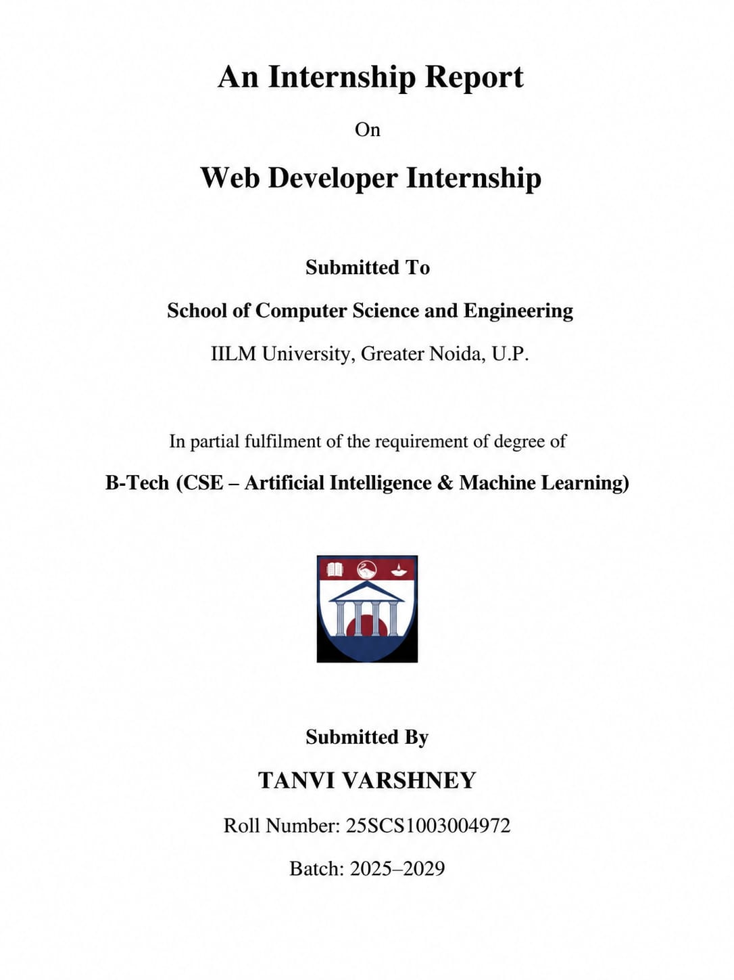

1. DECLARATION
I, Tanvi Varshney, hereby declare that this internship report is a record of the learning and project work completed by me during the one-month Web Developer Internship at Codec Technologies Pvt. Ltd.
This report has been prepared for academic submission to IILM University, Greater Noida, as a part of my B.Tech. programme in Computer Science and Engineering – Artificial Intelligence & Machine Learning.
The report presents my understanding of the concepts, technologies, development practices and project-related activities covered during the internship. The information and technical references used while preparing this report have been appropriately acknowledged.
I further declare that this report has not been submitted by me to any other institution for the award of any degree, diploma or academic qualification.

Name: Tanvi Varshney
Roll No.:25scs1003004972
Signature: ________

2. ACKNOWLEDGEMENT
I sincerely express my gratitude to Codec Technologies Pvt. Ltd. for providing me with the opportunity to participate in the one-month Web Developer Internship programme.
The internship gave me valuable exposure to practical web development and helped me understand how different technologies are combined to develop modern software applications. It allowed me to relate the concepts studied in my academic curriculum with real-world development practices.
I am thankful to the mentors and instructors associated with the internship programme for their guidance and support throughout the learning process. The internship helped me improve my understanding of front-end development, responsive web design, JavaScript, APIs, back-end concepts, databases, testing, debugging and deployment.
I would also like to express my gratitude to the School of Computer Science and Engineering, IILM University, Greater Noida, for providing academic support and encouragement.
Finally, I am thankful to my parents, friends and everyone who motivated and supported me during this internship.
TANVI VARSHNEY

3. CONTENTS
- Declaration
- Acknowledgement
- Contents
- Internship Certificate
- Overview of the Internship
  - 5.1 About the Training Organization
  - 5.2 Internship Learning Areas
- Project Study
  - 6.1 Project Background
  - 6.2 Need for the Proposed System
  - 6.3 Project Goals
  - 6.4 Functional Scope
  - 6.5 Technology Stack
  - 6.6 Overall Design
  - 6.7 Development Approach
  - 6.8 Major Components
  - 6.9 Anticipated Results
  - 6.10 Summary
- References

4. INTERNSHIP CERTIFICATE

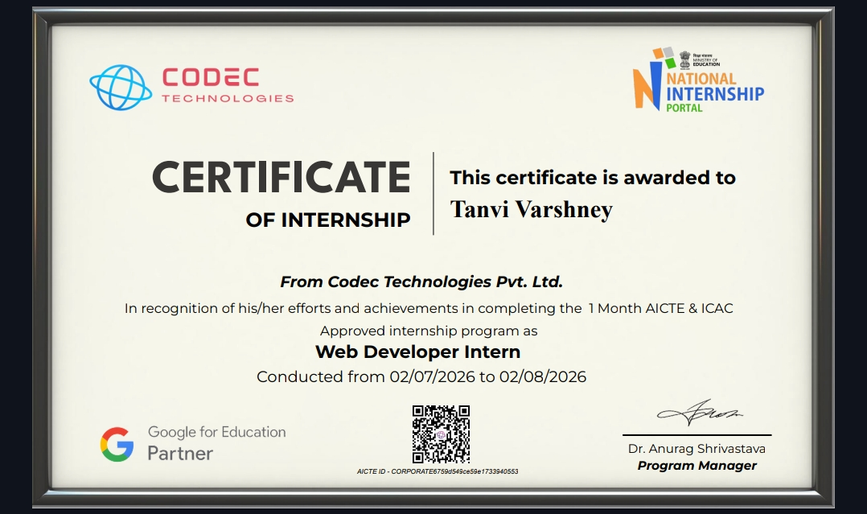

The internship certificate issued by Codec Technologies Pvt. Ltd. confirms the completion of the one-month internship programme. The certificate mentions Tanvi Varshney as the Web Developer Intern and records the internship period from 02/07/2026 to 02/08/2026.

-INTERNSHIP OFFER LETTER
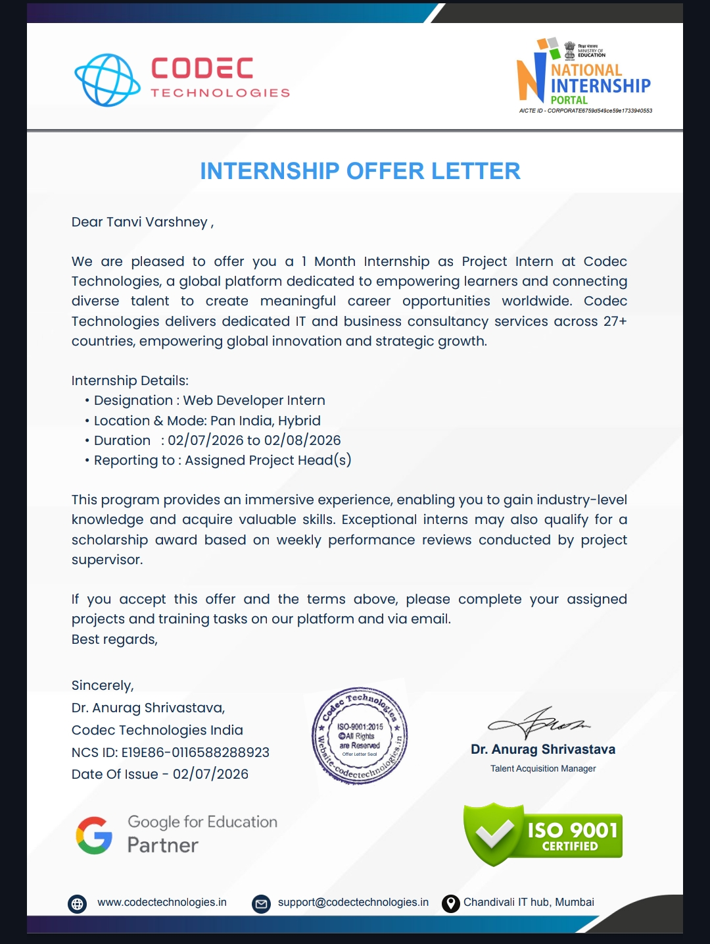

5. OVERVIEW OF THE INTERNSHIP

5.1 About the Training Organization
Codec Technologies Pvt. Ltd. was the organization through which the internship programme was undertaken.
The internship was designed to provide practical exposure to web development and the software development workflow. The programme introduced various concepts required for developing and maintaining modern web applications.
The learning journey covered basic web technologies initially and gradually moved towards more advanced development concepts. The internship provided exposure to front-end development, responsive interfaces, application programming interfaces, back-end technologies, databases, testing and deployment.
The structured nature of the programme helped in understanding how individual technologies can work together to create a complete application.

5.2 Internship Learning Areas
During the internship, the major areas of learning included:
- Development of web pages using HTML.
- Designing and formatting interfaces using CSS.
- Adding dynamic functionality using JavaScript.
- Understanding responsive web design.
- Learning concepts related to modern front-end frameworks.
- Understanding React.js and component-based development.
- Working with APIs and understanding client-server communication.
- Introduction to back-end development.
- Understanding database management and data storage.
- Learning basic testing and debugging practices.
- Understanding deployment and application development workflow.
- Improving knowledge of clean and structured coding practices.
The internship helped in developing a broader understanding of how a web application moves from an initial requirement to an integrated software solution.

6. PROJECT STUDY

6.1 PROJECT BACKGROUND
The major project considered during the internship is an AI-Powered Recruitment and Applicant Tracking System (ATS).
Recruitment involves several activities such as collecting resumes, managing applicant details, comparing candidate profiles with job requirements, monitoring selection stages and arranging interviews. When these activities are handled manually, managing a large number of candidates can become difficult.
The proposed project aims to provide a centralized web-based platform where recruitment-related information can be organized and accessed through a single system.
An important part of the project is the use of Artificial Intelligence and Natural Language Processing (NLP) for assisting in resume analysis. Resume information can be processed to identify relevant skills and compare them with the requirements of a particular job.
The system therefore combines web development with AI-based text processing to support the recruitment workflow. The reference project describes a combination of React.js, Python NLP, FastAPI and PostgreSQL for this purpose.

6.2 NEED FOR THE PROPOSED SYSTEM
Recruitment teams may receive a large number of applications for different job positions. Manually reviewing each resume and comparing every candidate with the requirements of a particular position can require significant time and effort.
Another challenge is maintaining candidate information in an organized manner. Recruiters need to keep track of applications, screening results, selection stages and interview details.
The proposed system attempts to address these challenges by creating a centralized recruitment platform.
The system can help organize candidate information, process resumes, identify skills, compare applicants with job requirements and maintain a visual representation of the recruitment process.
By bringing these activities together, the platform can provide a more structured approach to initial candidate screening and recruitment management.

6.3 PROJECT GOALS
The major goals of the project are:
- To develop a centralized platform for managing recruitment information.
- To maintain candidate profiles and job-related information.
- To process resumes and extract useful information.
- To identify relevant candidate skills using NLP techniques.
- To compare candidate skills with job requirements.
- To provide ranking assistance during initial screening.
- To maintain candidate progress through different recruitment stages.
- To organize interview-related information.
- To develop an interactive web interface for recruiters.
- To connect the front-end, back-end, AI processing and database components.

6.4 FUNCTIONAL SCOPE
The project focuses on the major activities involved in a basic digital recruitment workflow.
The proposed system covers the following functions:

Candidate Management
Candidate profiles and application information can be maintained in a centralized system.

Job Management
Recruiters can manage job descriptions and requirements for different positions.

Resume Processing
Submitted resumes can be processed to obtain relevant candidate information.

Skill Identification
NLP-based processing can assist in identifying technical and other relevant skills from resume content.

Skill Matching
The skills extracted from a candidate's resume can be compared with the requirements mentioned in a job description.

Candidate Ranking
Matching information can be used to support the ranking of candidates for an initial screening process.

Recruitment Pipeline
Candidates can be organized according to their current recruitment stage.

Interview Management
Interview-related information can be associated with candidates and their respective recruitment stages.

Application Integration
The system combines the front-end interface, API layer, AI processing and database into one application workflow.
The project is intended as an academic/proof-of-concept application. Specific production-level features such as exact AI models, authentication systems, external calendar integration and final deployment configuration may depend on the implementation.

6.5 TECHNOLOGY STACK
Technology | Purpose
React.js | Development of interactive front-end screens and recruiter dashboard
Python + NLP | Resume processing, skill extraction and AI-assisted screening
FastAPI | Development of APIs and communication between application components
PostgreSQL | Storage and management of structured recruitment information
The project stack combines a modern front-end framework, Python-based AI processing, an API-based back end and a relational database. The original project material identifies these technologies for the proposed platform.

6.6 OVERALL DESIGN
The application follows a layered architecture in which different components perform different responsibilities.
A recruiter interacts with the system through the web interface. The interface communicates with the back-end services through APIs. The back end handles application operations and communicates with the AI/NLP component and database.
The basic flow can be represented as:
Recruiter / User
↓
React.js Front End
↓
FastAPI Services
↓
Python NLP Processing
↓
PostgreSQL Database

Front-End Layer
React.js is responsible for providing the user interface. It can be used for dashboards, candidate management screens, job information and recruitment-stage views.

API Layer
FastAPI acts as the communication layer between the front end, processing logic and database.

AI/NLP Layer
Python-based NLP techniques can be used for processing resume content, identifying skills and assisting in candidate-job matching.

Database Layer
PostgreSQL is used for maintaining structured information such as candidate details, jobs, applications, pipeline stages and interview information.

6.7 DEVELOPMENT APPROACH
The project can be approached through multiple development stages.

Stage 1 – Requirement Analysis
The first step is to understand the recruitment workflow and identify the features required by the system.

Stage 2 – System Planning
The major screens, application modules, data flow and communication between components are planned.

Stage 3 – Database Design
The required data structures for candidates, jobs, applications, recruitment stages and interviews are defined.

Stage 4 – Front-End Development
The recruiter-facing interface and dashboard components are developed using React.js.

Stage 5 – API Development
FastAPI services are developed to manage application operations and communicate with the front end.

Stage 6 – NLP Integration
Resume content is processed to identify relevant information and skills for comparison with job requirements.

Stage 7 – Feature Integration
Candidate management, skill matching, ranking, pipeline tracking and interview-related functionality are connected.

Stage 8 – Testing and Improvement
The different modules and complete workflows are tested to identify errors and improve functionality and usability.
This development approach follows the project phases described in the reference material, while the wording and organization here have been rewritten.

6.8 MAJOR COMPONENTS

A. Resume Processing
The resume processing component focuses on extracting useful information from submitted resumes. Python and NLP techniques can be used to identify candidate details and relevant skills.

B. Skill Matching
This component compares the skills identified from a candidate's resume with the requirements of a particular job description.
The purpose is to provide an indication of how closely a candidate's profile corresponds to a given role.

C. Candidate Ranking
The system can use the matching information to assist recruiters in identifying candidates who appear more relevant to a particular job.

D. Hiring Pipeline
The hiring pipeline provides a structured representation of candidates at different recruitment stages.
This makes it easier to monitor candidate progress throughout the recruitment workflow.

E. Interview Management
Interview-related information can be maintained along with candidate records and recruitment stages.

F. Recruiter Dashboard
The dashboard acts as the central interface through which recruiters can access candidate information, job details, screening information and recruitment progress.
These components correspond to the major project modules described in the supplied internship material.

6.9 ANTICIPATED RESULTS
The proposed system is expected to provide the following outcomes:
- Better organization of recruitment information.
- Centralized management of candidate profiles.
- Easier access to job and application details.
- AI/NLP-assisted resume processing.
- Faster identification of relevant candidate skills.
- Comparison between candidate profiles and job requirements.
- Assistance in initial candidate ranking.
- Better visibility of recruitment stages.

Organized interview-related information.
- Practical understanding of full-stack application architecture.
- Experience in connecting React.js, Python NLP, FastAPI and PostgreSQL.
The expected outcomes are consistent with the project objectives and features described in the source report.

6.10 SUMMARY
The AI-Powered Recruitment and Applicant Tracking System demonstrates how web technologies and AI-based processing can be combined to address a practical recruitment problem.
The project brings several recruitment activities into a centralized platform. These include candidate management, job requirements, resume processing, skill comparison, candidate ranking, recruitment-stage tracking and interview information.
From a technical perspective, the project provides exposure to a multi-layer application architecture. React.js is used for the front-end experience, FastAPI provides the API layer, Python supports NLP-based processing, and PostgreSQL provides structured data storage.
The internship therefore provided an opportunity to understand how different technologies interact within a complete application and how theoretical programming concepts can be applied to a practical software-development problem.

7. REFERENCES
- Codec Technologies Pvt. Ltd. – Internship programme and project information.
- React.js Documentation – Official documentation and reference material for React development.
- FastAPI Documentation – Official documentation for API and back-end development.
- Python Documentation – Official Python language and library reference.
- PostgreSQL Documentation – Official documentation for PostgreSQL database management.
- IILM University, Greater Noida – School of Computer Science and Engineering.

